APEN Support for
Regional Events Program

What is APEN?
The Australasia-Pacific Extension Network is the leading professional association for people whose job involves facilitating change in regional communities. The APEN network represents approximately 450 extension professionals.
APEN plays an essential role in coaching, mentoring, assisting and developing extension professionals so that they can make a difference in rural and regional industries and communities into the future.

What is the APEN Small Grants for Regional Events Program?
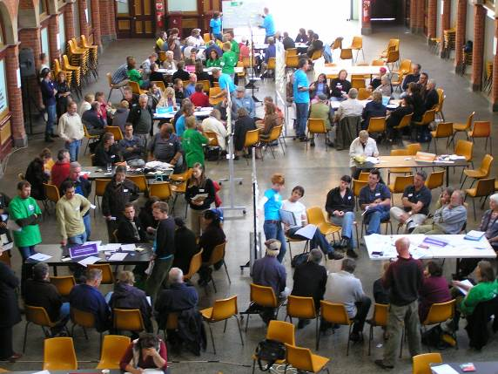The APEN Small Grants for Regional Events Program will provide grant funding and/or seed funding to assist individuals and organisations to access the initial funding required to organise and provide regional activities in line with APEN’s objectives. A key goal of APEN is to foster professional development opportunities for people working in all areas of extension.
Applicants can apply for either small grant funds (<$250) or seed funding (<$1000).
Small grant funds will be provided without expectation of any funds being returned to APEN.
Seed funding will be provided with the expectation that these funds will be recouped, i.e seed funding and an agreed percentage of profitswill be returned to APEN at completion of the event.
The APEN Management Committee will select projects that they believe will contribute to the development of the extension profession in Australia, New Zealand and the broader Australasia-Pacific region. In an endeavour to promote and foster novel and innovative projects there is no specific criteria for the program, other than projects must contribute to the professional development of people working in extension in a networking context. Applications in the current round of funding can be submitted at any time before 30 June 2014.

Who Can Apply?
APEN members and/or organisations with an interest in rural and regional extension are able to apply for funds.

What will applicants need to do?

Applicants will be required to
- Complete the application form and provide details of the project
- Complete a financial acquittal detailing actual income and expenditures at the completion of the project.
- Return seed monies and profit share to APEN as agreed within the required timeframe following the event.
- Complete a one page report following the event on the key outcomes from the event and how they will benefitextension professionals.
- Acknowledge the support of APEN in the publicity, publications and any media / press release

For More Information

APEN Secretariat: | Rosemary Currie  Phone 02 6024 5349 | info@apen.org.au

APEN Small Grants for Regional Events Program
Application Form

Project Title:

Applicant/Contact person Name:

Organisation:

Address:

Town: P/Code:

Email:

Phone: Fax:

Are you APEN MemberNon APEN Member?

Provide a brief description of your proposed Event.

Provide a brief description of proposed outcomes from the event.

Who is the target audience and anticipated attendance

What benefit will be gained by your extension profession through participation in this project?

How will the project be publicised and promoted?

How will you promote APEN at your event and through your publicity?

Are you applying for:Grant FundingSeed Funding?

Total Funding Requested

Percentage of Profits returned to APEN
Proposed budget
Income | Details | Cost
Grant funding |  | $0.00
Seed funding |  | $0.00
Event fees |  | $0.00
Sales |  | $0.00
 |  | $0.00
 |  | $0.00
 | Total | $0.00

Expense Type | Details | Cost
Return APEN seed funding |  | $0.00
Venue hire |  | $0.00
Printing & materials |  | $0.00
Media & publicity |  | $0.00
Catering |  | $0.00
 |  | $0.00
 |  | $0.00
 | Total | $0.00

Lodging Your Application Form: Email: info@apen.org.au
Please attach any supporting documents.

For More Information

APEN Secretariat: | Rosemary Currie  Phone 02 6024 5349  info@apen.org.au
APEN Website |  | http://www.apen.org.au

